StoryBoard

First you can draw the game items by your self such as the player,the enemy and the weapon,

Second you can use your finger to control the player moving around in the whole game and play this game designed by yourself. You can also shoot and eat and avoid those enemies.

The main part is mainly two steps:

1: draw

2: play

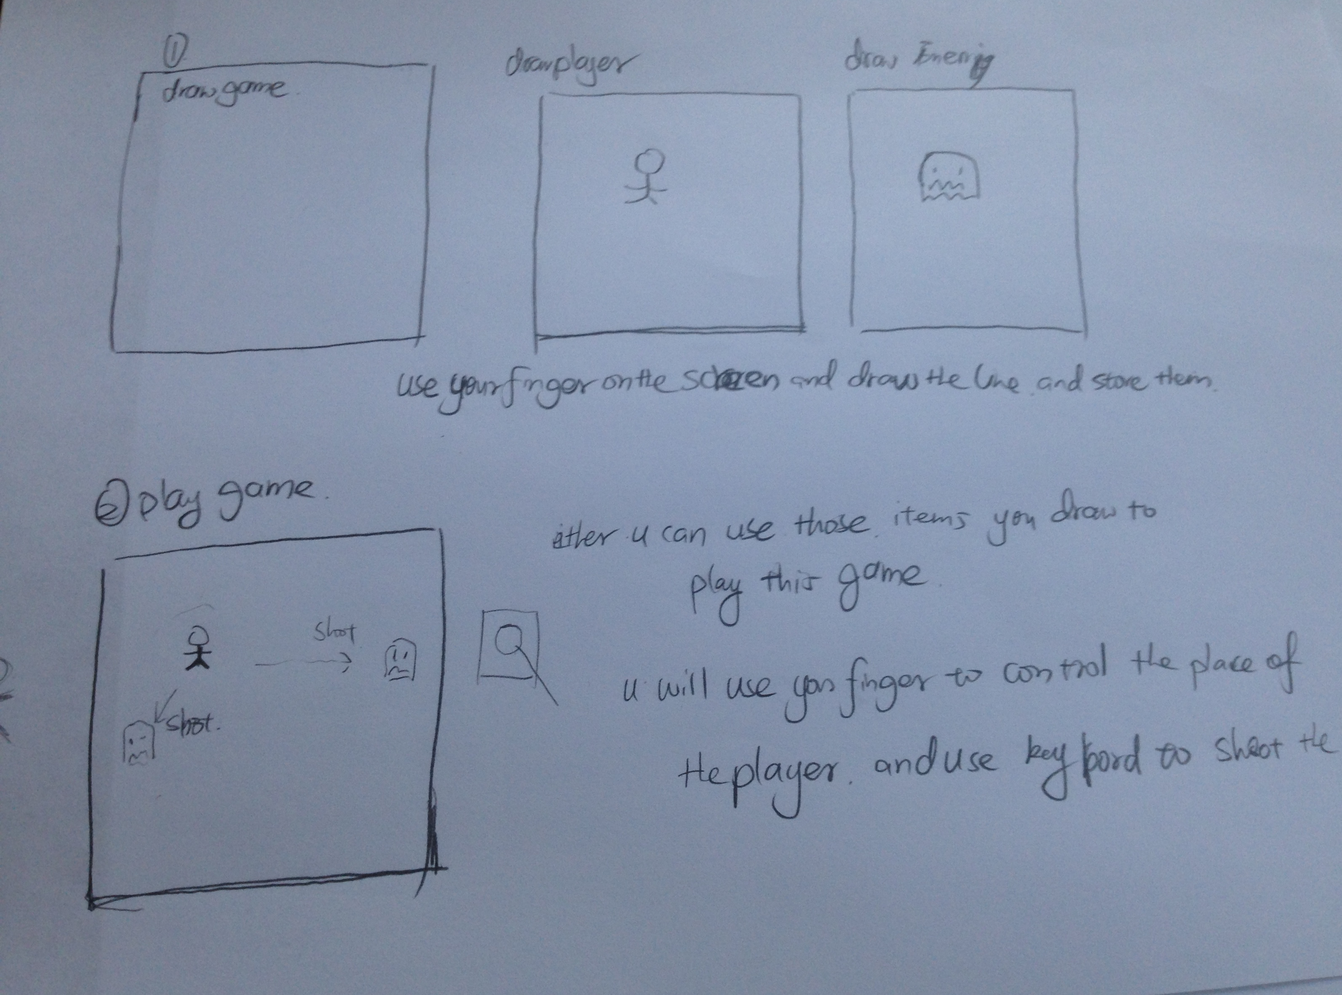

all you will do is just use your finger or hand to control the whole movement of those things.